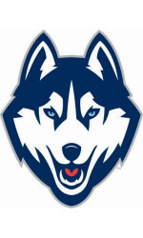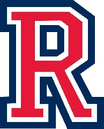

Huskies Sports Medicine

Reno High School 395 Booth St. Reno, NV 89509

Phone (775) 333-5050

**Washoe County School District Concussion Protocol**

* Upon a suspected concussion, the athlete is to be seen by an MD for diagnoses. We often utilize Dr. Stovak and his associates at the Family Medicine Center at the University of Nevada: <https://med.unr.edu/fmc/contact>

You can choose to see another MD if preferred.

* You will need to keep track of your daily symptoms (symptom card is following instructions)
* Athlete will also want to contact counselor to let teachers know of current situation
* Within 72 (48 is preferred) hours after the suspected injury, athlete needs to schedule an appointment with the Athletic Trainer: Alyson Rippingham to go through a post injury VOMS. Once althlete is symptom free they will do another VOMS as well as take a post injury ImPact test for clearance.
* Scores will be sent to Dr. Murray at the University of Nevada for clearance and the return to play protocol to begin.
* **Until athlete is cleared he or she is NOT allowed to participate in any form of practice/weights/or PE.**